4.2: In the new coordinates, the 120-N force acts at an angle of 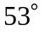 from the -axis, or 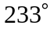 from the 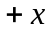-axis, and the 50-N force acts at an angle of 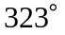 from the -axis.

a) The components of the net force are
b) 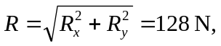 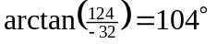. The results have the same magnitude, and the angle has been changed by the amount 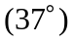 that the coordinates have been rotated.

